**Advance Excel Assignment 1**

**1.What do you mean by cells in an excel sheet?**

Ans: Cells are the boxes you see in the grid of an Excel worksheet, like this one. Each cell is identified on a worksheet by its reference, the column letter and row number that intersect at the cell's location. This cell is in column C and row 4, so it is cell C4. The column always comes first in a cell reference

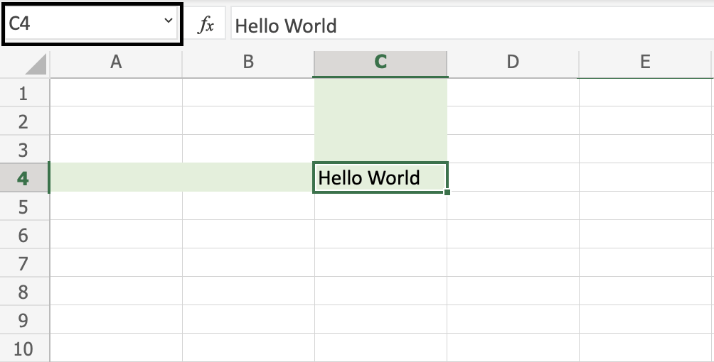.

**2. How can you restrict someone from copying a cell from your worksheet?**

The standard approach is to protect the workbook. (Use the Protect Workbook tool on the Review tab of the ribbon.) Provided you protect the structure, Excel will disable the Move or Copy Sheet option.

3. How to move or copy the worksheet into another workbook?

You can use the **Move or Copy Sheet** command to move or copy entire worksheets (also known as sheets), to other locations in the same or a different workbook. You can use the **Cut** and **Copy** commands to move or copy a portion of the data to other worksheets or workbooks.

* Press CTRL and drag the worksheet tab to the tab location you want.

OR

1. Right click on the worksheet tab and select **Move or Copy.**
2. Select the **Create a copy** checkbox.
3. Under**Before sheet**, select where you want to place the copy.
4. Select **OK.**

**4.Which key is used as a shortcut for opening a new window document?**

**Ans: CTRL + N**

**5. What are the things that we can notice after opening the Excel interface?**

This is the layout used in Excel 2007. The layout in Excel 2010 and Excel 2013 and later versions of Excel are almost identical. The key components are as follows:

**Title Bar** – contains the name of the workbook. The default is Book1 (and then Book2, etc.). This is replaced by the filename once the Excel workbook is saved.

**Worksheet Tabs** – a list of all the worksheets in the workbook. By default, these are labeled Sheet1, Sheet2, etc. You can navigate to any worksheet in the workbook by clicking on that worksheet tab. You can also use the four small arrows [Tab Arrows Icon](https://real-statistics.com/wp-content/uploads/2013/02/image006.png) to the left of the worksheet tabs for navigation purposes. The first arrow is used to go to the first worksheet, the second to go to the previous worksheet, the third to go to the next worksheet and the fourth to go to the last worksheet. You can change the name of any of the worksheets by doubling clicking on its tab and then entering a new name. You can add a new worksheet by clicking on the rightmost worksheet tab icon [New Worksheet Tab Icon](https://real-statistics.com/wp-content/uploads/2013/02/image007.png). You can also change the order of the worksheets in the list by left-clicking on a worksheet tab and dragging it to a new location in the list. You can access other capabilities by right-clicking on any of the worksheet tabs or the worksheet tab arrows.

**Ribbon Tabs** – the top-level menu items. In the example above this consists of **Home, Insert, Page Layout, Formulas**, etc. The actual choices can change depending on the state that you are in. To access most capabilities in Excel you click on one of these ribbon tabs. For each tab, a different ribbon will be displayed. In Figure 1 the **Home** ribbon is displayed. This tab provides access to the most common Excel capabilities.

**Ribbon** – a collection of Excel capabilities organized into **groups** corresponding to some ribbon tab. For example, the **Home** ribbon displayed in Figure 1  is organized into the **Clipboard, Font, Alignment, Number**, etc. groups. Each group consists of one or more **icons** corresponding to some capabilities in Excel. For example, to center the content of a cell in a worksheet, click on that cell and then click on the center icon [Excel Center Text Icon](https://real-statistics.com/wp-content/uploads/2013/02/image008.png) in the Alignment group on the Home ribbon. We use the following abbreviation for this sequence of steps: **Home > Alignment|Center**. 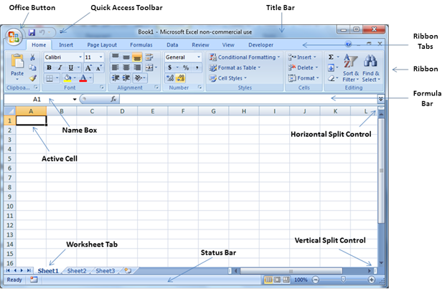

**6.When to use a relative cell reference in excel**

Ans:The relative reference makes the cells reference free. It gives the fill function freedom to continue the order without restrictions.